xValley Engineer Newsletter
October, 2019

UPCOMING PROGRAMS
11/12/2019 LVPSPE Chapter meeting,
400 Boulder Drive, Breinigsville, PA

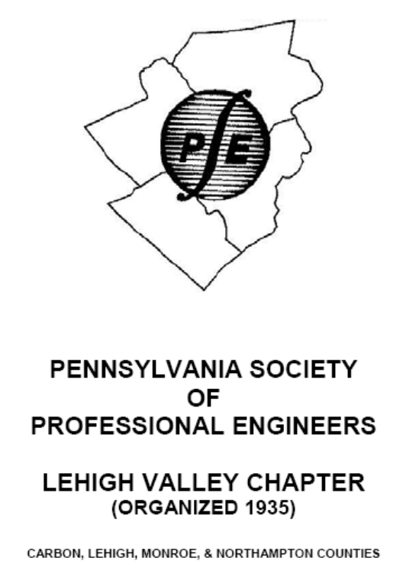

President’s Message
Alex Dezubay, PE

Last month I asked our Lehigh Valley member and current PSPE President Mike Basta for PSPE’s answer to the question “Why should a PE join NSPE and PSPE?” Mike pointed me to NSPE’s website https://www.nspe.org/membership/member-benefits. While none of these NSPE benefits alone are reasons to join, together they make a case to join or maintain membership.

NSPE offers:
- Fifteen free courses on-line all are offered with PDHs.
- Communities to connect with colleagues to share knowledge.
- Continuing education courses including webinars and live events.
- Networking opportunities through blogs, conferences and state and local chapters.
- Advocacy and Outreach to promote the engineering and licensing by tracking legislation and interacting with lawmakers. Advocacy also reaches out to young people through MATHCOUNTS and scholarship programs.
- PE magazine is published six times per year; it offers commentary on licensing, ethics, employment, legislative and regulatory matters that impact engineers.
- NSPE job board publicizes job openings.
- Benefit partners includes discounts on publications and standard contract documents.

PSPE employs Wanner Associates in Harrisburg to advance the interests of the engineering profession in Harrisburg with our state legis-lators. More on these state benefits later.

Remarks by 2019-2020 PSPE President, Michael Basta, 2019 PSPE Conference, September 20, 2019

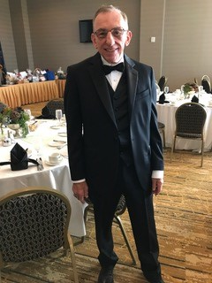

Good evening, I am very excited and humbled to be standing here tonight as your new president. I truly hope that I can uphold the legacy of the hardworking, dedicated presidents who have preceded me.

I also want to thank the past and present board members. I have enjoyed working with you on various projects and look forward to your continued support and assistance during the upcoming year. Thank you for your service and contributions.

This conference would not have been possible without the hard work and dedication of our conference committee and Jennifer Summers and her team. They work behind the scenes to secure speakers, plan programs, and ensure that we have great facilities. To each of you, thank you.

Our president for the past year was Steven J. Novotny. I thank you for your leadership, dedi-cation and strategic planning. You have made great strides for the organization during your tenure and I hope to continue to build on that progress.

As most of you know, Steve is a graduate of Pitt and I am a graduate of Penn State, but we work well together and get along 364 days a year. However, there is one day each fall when we are mortal enemies; the day of the Penn State – Pitt football game! So, what was the final score of the game last week, Steve?

My grandparents were immigrants from Italy and arrived in the United States through Ellis Island in 1902. They spoke very little English, but managed to build a home, raise a family, and become citizens. They would have been so proud to know that their grandson had become a professional engineer and that he was elected PSPE PRESIDENT!

Within the last year, the NSPE adopted a change to the code of ethics to the professional obligations for professional engineers. This code now reads that Engineers shall treat all persons with dignity, respect, fairness, and without discrimination. I truly believe that PSPE members fulfill those obligations daily and provide an excellent example for other professions. They provide a wonderful example of the meaning of professional engineer.

As your new President I want to focus on two areas of concern that continue to be a challenge across the state.

First, there is a need to increase the number of professional engineers participating in the Society and also increasing the number of new engineers obtaining their professional licenses. Currently we have professional engineering chapters at Wilkes, Penn State, and Villanova Universities. These organizations support, encourage and inform engineering student in achieving their goals and encourages them to obtain their licenses. I recently spoke with a young woman just beginning her engineering career after graduating from a university. She said that no one had even spoken to her about the advantages of getting a professional license! I am hoping that we can change that by organizing chapters at other universities.

Continued on page 3
My second goal is to continue our efforts to protect and maintain the integrity of our licenses. It is important for us to continue to work with regulatory agencies, local and state officials, and the general public to ensure that standards are not reduced. It is our responsibility to inform both officials and the public that professional engineers are needed to protect public health, safety and welfare. We must protect the License. We must continue to encourage other professional organization to work with us as they do in other states for common cause. This is not just the job of our officers and board, but the role of every member of every chapter. Take the time to communicate at every opportunity with the general public and our legislators.

Over the next year. I hope to attend local chapter meetings. I hope that these meetings will provide an opportunity for you to voice your concerns and share your ideas.

I will leave you with this thought:
Resolve to be tender with the young,
Compassionate with the aged,
Sympathetic with the striving,
Tolerant of the weak and the wrong.
Sometime in life you will have been all of these!

Thank you very much.

As the 2019 conference comes to an end I hope you enjoyed the meeting with fellow engineers. And that you gained new knowledge to apply to your profession.

Thank You
----------------------------------------------------

When I’m in a slump, I comfort myself by saying if I believe in dinosaurs, then somewhere, they must be believing in me. And if they believe in me, then I can believe in me. Then I bust out.
-Mookie Wilson

----------------------------------------------------

You can get a lot farther with a kind word and a gun than you can with a kind word alone.
-Al Capone.

A Foodie in Israel
Alfred Gruenke, PE

One of the pleasures of international travel is to be able to partake of the various cuisines the countries of the world have to offer. In the United States we are blessed with many foods with an international flavor, but there is nothing better than going to the source, the home of the many varieties of fuel that keeps us alive.

First the disclaimer. I’m a foodie. I like food and make no apologies for it. I have also on occasion enjoyed squeezings of grapes, and fermentations and brewings of various grains. I firmly believe one should never eat on an empty stomach; there is a sound engineering reason for this. If food falls into an empty stomach it could damage the lining. With food present the food acts as a “rock box”, softening the blow, and reducing the possibility of damage. Isn’t rationalization wonderful? My waistline and gravitational attraction are a testament to my passion!

I’ve been to fifty countries or so, and there have been very few places that I didn’t like the food. Notable exceptions have been Mongolian food and Nigerian pepper soup. The former had seasoning that just didn’t appeal to me and the latter was so hot it was akin to eating burning napalm.

When we think of Israel we normally think of Jerusalem, Mosque of Aqsa, Bethlehem, and other places that are sacred to three religions. We normally don’t think of Israel as an epicurean destination, because it’s not. At least not “official” cuisine.

Most of the world’s foods have at least a modicum of spices to give the base food some flavor. The heritage of traditional Israeli cooking is Russian, that huge country that somehow managed to evade the import of spices that most of Europe has enjoyed since the Middle Ages.

I was staying in a local hotel in Beersheba, the location of Abraham’s well and a bit of a back-water. The hotel restaurant’s cuisine was tradi-tional. The waiter placed a hunk of meat and a

Continued on page 14

SCHOLARSHIP SPONSORS

A great way to be involved in the LVPSPE Chapter is to contribute to the LVPSPE SCHOLARSHIP FUND. Please Contact the Valley Engineer Editor to sponsor scholarships for the remainder of the calendar year.

If you would like to contribute in any amount –please send your TAX DEDUCTIBLE donation to PA ENGINEERING FUND. Donations should be mailed to:

LVPSPE
P.O. Box 3441
Allentown, PA 18106

Please note “LVPSPE Scholarship Fund” on the comment line.

Or, you may also contribute via the LVPSPE website http://www.lvpspe.org/Donations.

Scholarship application is at http://www.lvpspe.org/Scholarships. Any questions regarding scholarships can be directed to
Alex Dezubay, PE
610-597-2007
Scholarship@LVPSPE.org

PSPE SCHOLARSHIPS
The Pennsylvania Engineering Foundation currently administers the following scholarships for engineering students:

Undergraduate
- $1,000 PEF Grant: (2 awards)

Upperclassman
- $2,000 Pennsylvania Engineering Foundation Grant

Applications and guidelines are on-line now at http://www.pspe.org/scholarships

2018 – 2019 LVPSPE SCHOLARSHIP DONORS

Graduate
American Society of Civil Engineers
Lehigh Valley ASCE, Bethlehem, Pennsylvania.
Lutron Electronics Co., Inc.
Coopersburg, PA

Senior
FLSmidth, Inc.
Bethlehem, PA
PPL Corporation
Allentown, PA
Victaulic Company
Easton, PA

Junior
Barry Isett & Associates
Allentown, Phoenixville, Hazleton, Wilkes-Barre,
Liberty Property Trust
Bethlehem, PA
Mary Rooney/EnviroAce
Allentown, PA
Millenium Electro-Hydraulics Services
Whitehall, PA
Pennoni Associates, Inc.
Bethlehem, PA
The Pidcock Company
Allentown, PA

Sophomore
Borton Lawson Engineering
Bethlehem, PA
Bosch-Rexroth
Bethlehem, PA
Hanover Engineering Associates
Bethlehem, PA
Mass Mutual Financial Group
Center Valley, PA
Monarch Precast Concrete Corporation
Allentown, PA
Newton Engineering
Allentown, PA
Rettew
Lancaster, PA

Continued on page 13
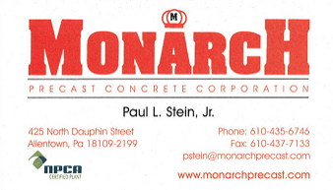
Monarch
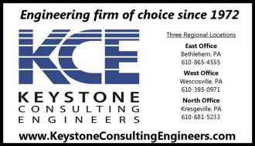
Keystone
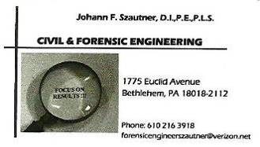
Civil Forensic Peruzzi
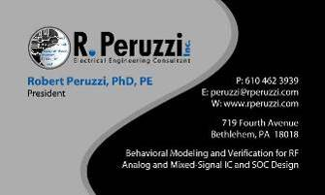
Peruzzi

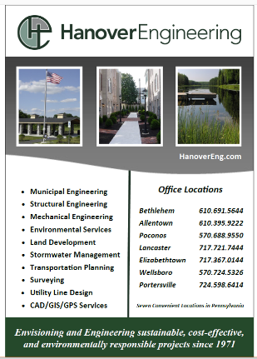
Newton-Hanover
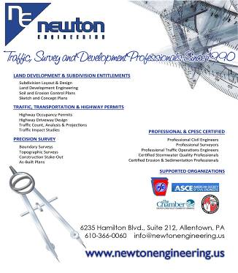

Minuteman
Kohn
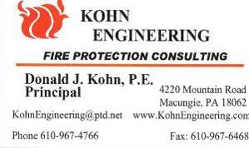

Michael F. Basta, PE

Bazella Group
K
Kevin Campbell, PE
Peak
William Erdman. PE

P
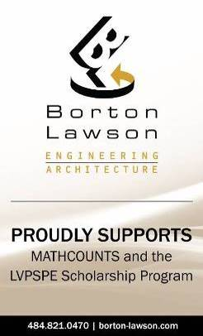

Borton Lawson
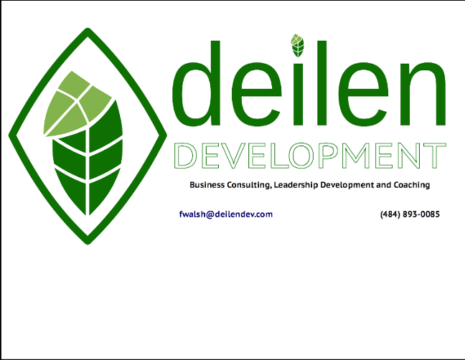
Deilen

Alfred Gruenke, PE

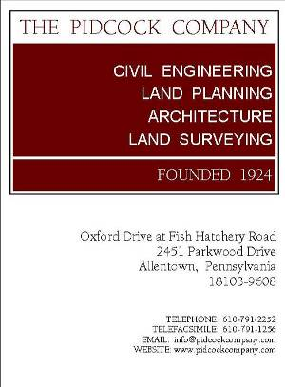
Pidcock Rettew
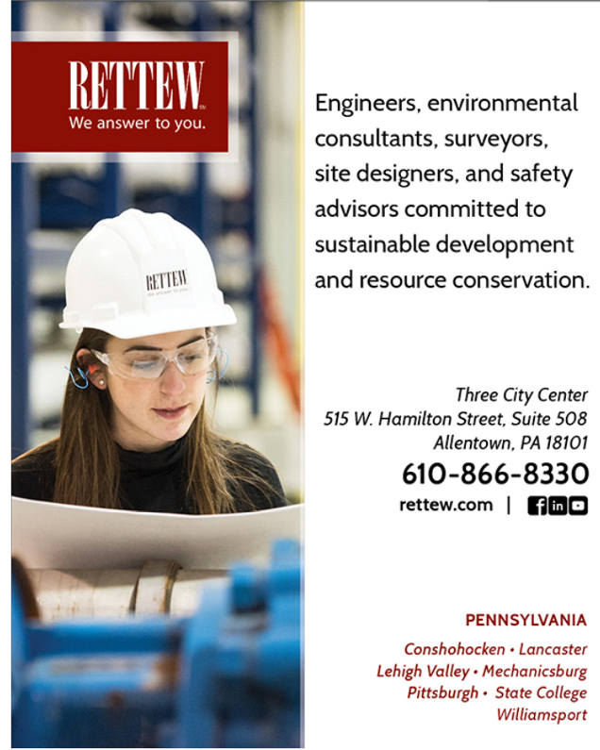

Pennoni 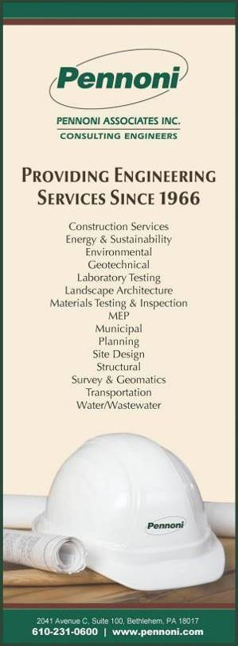

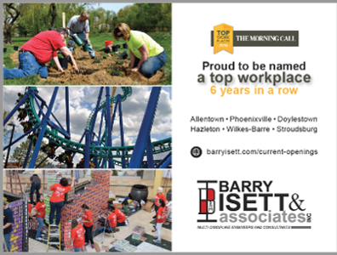
Barry Isett

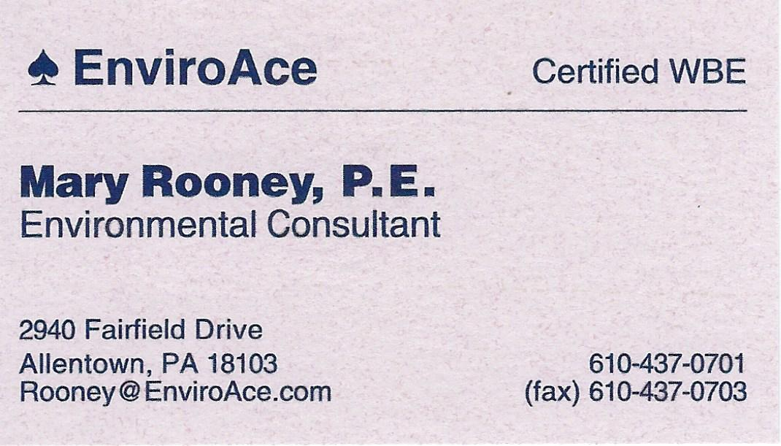
EnviroAce

Iset Lutron MUTUAL Isett
Hanove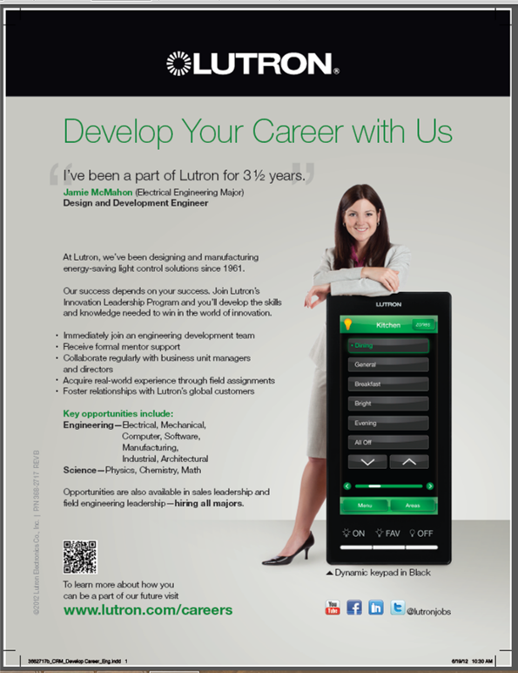

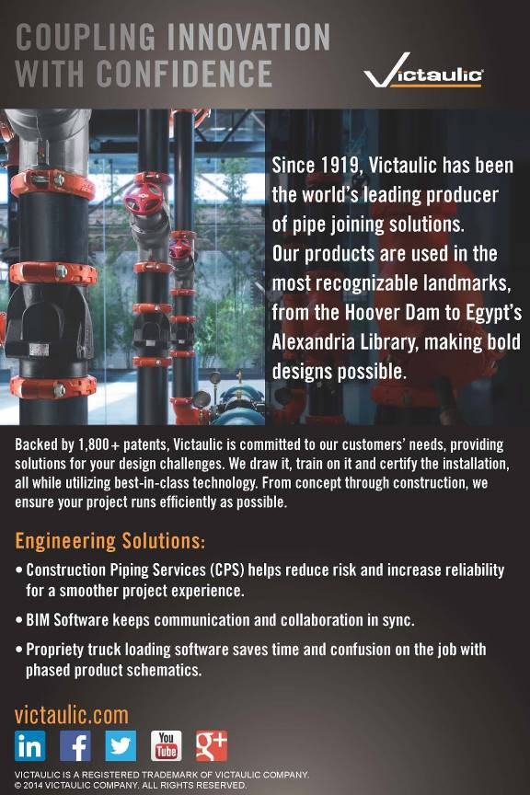

Victaulic


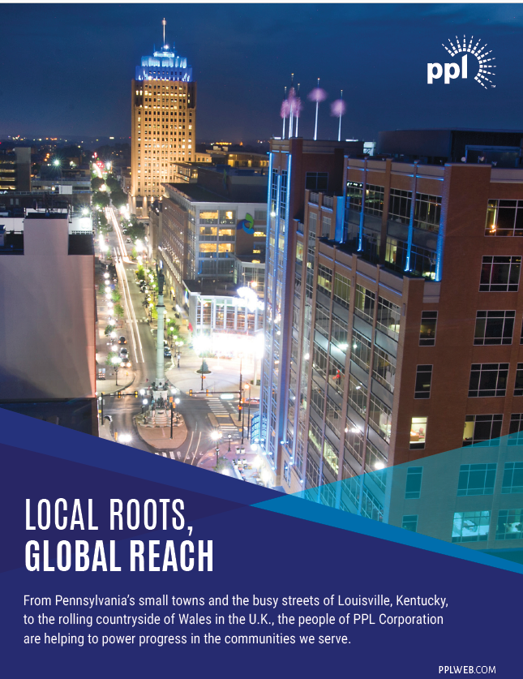

Internet Addresses

National Society of Professional Engineers
www.NSPE.org
Pennsylvania Society of Professional Engineers
www.PSPE.org
Lehigh Valley Chapter – PSPE
www.LVPSPE.org

2019 – 2020 State Officers

State Director
Peter Staffeld PhD, PE, F.NSPE
StateDirector@LVPSPE.org 215-536-7075

Alt. State Director
Angelicaka Fordran, PE
610-997-6659
VP Northeast:
Marleen Troy, PE, PhD
570-408-4615

Board of Direction Meetings

The monthly Board of Direction meetings are 6:00 PM on the second (2nd) Monday of each month. Open to all members; they are held at the office of Liberty Property Trust, 74 W. Broad Street, Suite 240, Bethlehem, PA.

2019 – 2020 Chapter Officers

President:
Alex Dezubay, PE
President@LVPSPE.org 610-997-6659

Vice President:
Jeff Kutz, PE
VicePresident@LVPSPE.org 610-597-2007

Secretary:
Chris Williams, PE, LEED AP
Secretary@LVPSPE.org 610-398-0904

Treasurer:
Ray Szczucki, PE
Treasurer@LVPSPE.org 610-614-1245

Immediate Past President:
Brian Kutz, PE 610-395-6561
PastPresident@LVPSPE.org

Chapter Directors:
Frank Walsh, PE
Directors@LVPSPE.org

Mary Rooney
Directors@LVPSPE.org

Alexa Rooney, EIT
Directors@LVPSPE.org

2018 – 2019 LVPSPE SCHOLARSHIP DONORS (continued)

Freshmen
Alfred Gruenke, PE
Civil & Forensic Engineering
Bethlehem, PA
Deilen Development

Kohn Engineering
Macungie, PA
R. Peruzzi, Inc.
Bethlehem, PA

Contributors
Michael F. Basta, PE
Bazella Group
William Erdman, PE
Kevin Campbell, PE
Keystone Consulting Engineers

Miller

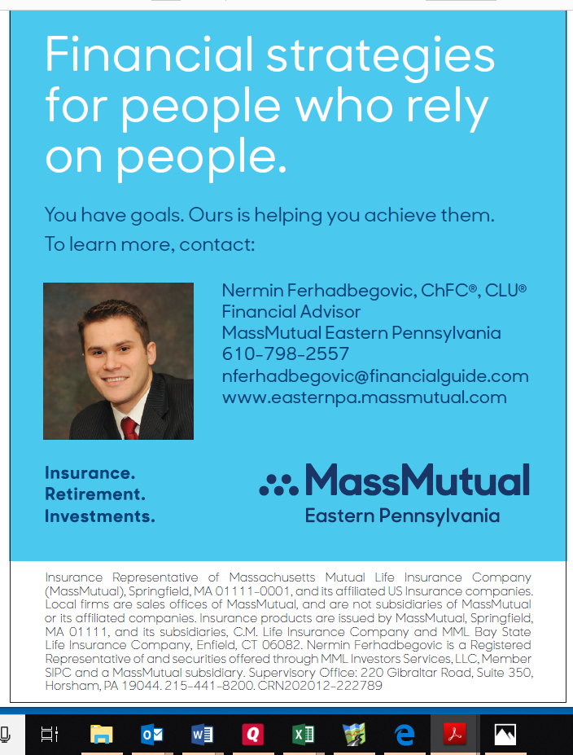
Mas
---------------------------------------
boiled potato in the plate, beaming with pride at the opulence of the offering. And I didn’t pack any hot sauce! I ate there until I found alter-natives which, fortunately, were plentiful and close. Israelis come from a multitude of coun-tries, and many of them have opened up small restaurants. My favorite was one that had Romanian food. Also, one cannot tour Israel without trying pita bread stuffed with various meats and vegetables. I also enjoyed the offerings of various Palestinian restaurants in the area, especially their salads.

Wine and vineyards have been a tradition in Israel since ancient times and have continued to this day. According to a religious teacher I once had wine was commonly drunk because the water in Israel tasted so bad. A popular brand, “Avdad”, is named after a mountain top fortress that withstood a 27-year siege by Cleopatra’s army. The label was in English except for a phrase “And there is no possibility of (Hebrew writing)”. I questioned that and was told that it is a guarantee that the grapes are from vines that are at least three years old. Apparently there

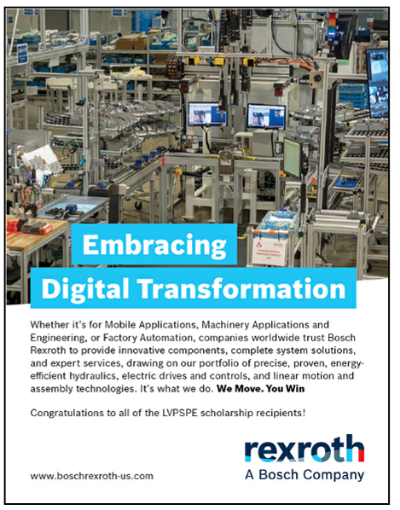

----------------------------------------------
is a religious taboo to wine from young vines. The wine was pretty good. Also, Christian Brothers monks have a monastery in Emaus, located along the Tel Aviv-Jerusalem highway. Surrounded by vineyards, its main industry is wine making and a shop that sells to the public. That wine was pretty good too.

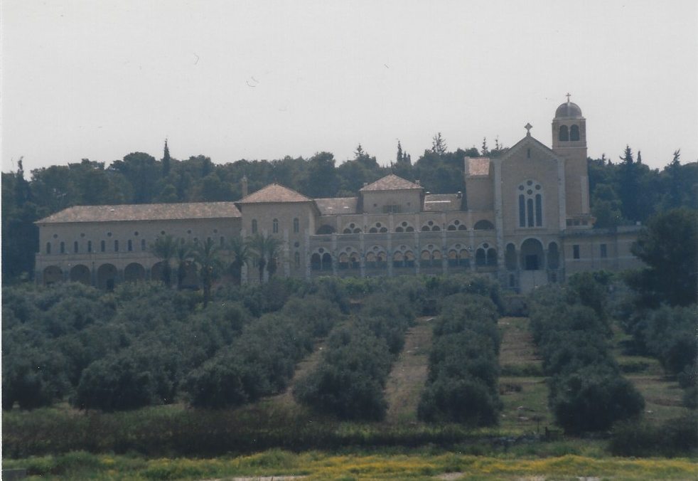

Christian Brothers Monastery – “On the road to Emaus”

Continued on page 15
I went to the monastery for Easter church servi-ces, but even though they had a chapel they weren’t geared up for public services. Instead I went to Kaiser Wilhelm’s Retterkirche, a short distance from the Church of the Holy Sepulcher in Jerusalem. They served wine and pita bread for Communion.

The local liqueur is called “Sabra” which is as good as or better than traditional liqueurs from France. “Sabra” is the name given to Israelis born in Israel. Unfortunately, this is not available here in Pennsylvania.

The local beer, brand name “Maccabee”, was pretty good, as was “Gold Star”, a franchise of Budweiser.

As I stated before, the standard hotel restaurant fare was pretty bland, except for breakfast.

That greatest (and only) culinary invention of Britain, ham or bacon and fried eggs with toast for breakfast was not on the menu, so I ate what was offered. Pickled herring and rye bread, tomatoes and bell peppers in a salad along with coffee. Sometimes, for a treat, we had lox and rye bread. This to me it was manna from heaven! When I was growing up pickled herring, lox, and rye bread was a special treat; eating it daily put me in “hog’s heaven” so to speak. I still enjoy such fare on occasion for lunch, with a cup of coffee.

Things changed during Passover. Instead of rye bread we were given crackers that had the flavor of unsalted cardboard. Furthermore, eons ago some wise man who was obviously a teetotaler and a sadist decreed that beer was akin to leaven bread, so everyone had to abstain during Pass-over. Liqueur and wine were acceptable, but beer was not. Fortunately, the gas station outside of town sold six packs in aluminum cans, as God intended beer to be quaffed.

So what was the result of my somewhat esoteric diet? My tour in Israel was for ten weeks. I lost ten pounds, was slimmer, had more energy, and felt great!

I came home and landed at JFK airport in New York. A driver picked me up to take me home. For some reason he drove through Manhattan, where I spotted a sidewalk hot dog vendor. I got out of the car and told the driver to drive around the block then pick me up. Two hot dogs with sauerkraut and mustard and a can of Coke revived my latent gourmand taste buds. Life is good.

-------------------------------------------------------



